**2025年兰州市初中学业水平考试**

**英语**

**注意事项:**

**1. 全卷共 90 分, 考试时间 90分钟。**

**2. 考生必须将姓名、准考证号、考场号、座位号等个人信息填（涂）写在试卷及答题卡上。**

**3. 考生务必将答案直接填（涂）写在答题卡的相应位置上.**

**4. 考试结束后, 将本试卷和答题卡一并交回。**

**一、完形填空（共10小题: 每小题1分, 满分10分）**

**阅读下面短文, 从短文后各题所给的四个选项中选出能填入空白处的最佳答案。**

Bob was a shy boy of 14. He always lowered his head. One Sunday afternoon, his ____1____ was busy taking care of his sick sister at home, so she had to ask Bob to help her sell home-made juice in their eating house.

At first, Bob just sat at the table in silence. And nobody came to ____2____ the juice. He felt bored and sleepy. After a while, a sweet voice came to his ears, “Hi, how much is the orange ____3____?” He said in a ____4____ voice, “Two dollars a cup.” Then he noticed a lady with a little girl standing in front of the table. When he ____5____ the look of joy on their faces, he smiled back.

“It looks nice! Is it made by yourself?” asked the girl. Bob nodded gently. The girl ____6____ again, “Cool! How did you make it?” “Well, um, I...” He began ____7____. “My mum taught me to make it. First, peel the fruit. Then, cut it into pieces...”As he was talking with the girl, some passers-by stopped to listen, too. Bob raised his head and began to speak louder.

Later, Bob’s mother came back. To her surprise, she found only a few cups left. “Good boy, what ____8____ progress you’ve made!” said his mother with a big smile. At that time, Bob realized ____9____ he raised his head, he would have more confidence.

Self-confidence is a kind of power. It can ____10____ the best in all of us.

1. A. mother B. father C. uncle D. aunt

2. A. make B. buy C. sell D. send

3. A. cake B. bread C. juice D. coffee

4. A. low B. high C. long D. short

5. A. smelt B. beard C. touched D. saw

6. A. told B. asked C. answered D. called

7. A. slowly B. seriously C. sadly D. quickly

8. A. no B. little C. great D. small

9. A. before B. no matter how C. unless D. as long as

10. A. take out B. give out C. help out D. bring out

【答案】1. A 2. B 3. C 4. A 5. D 6. B 7. A 8. C 9. D 10. D

【解析】

【导语】本文讲述害羞的Bob在帮妈妈卖果汁时，通过与顾客互动逐渐建立自信的故事，说明自信能激发出最好的自己。

【1题详解】

句意：一个周日的下午，鲍勃的妈妈正忙着在家照顾生病的妹妹，所以她不得不让鲍勃去他们的小餐馆帮忙卖自制果汁。

mother妈妈；father爸爸；uncle叔叔；aunt阿姨。根据下文“Later, Bob’s mother came back. To her surprise, she found only a few cups left.”可知，是妈妈忙于照顾生病的妹妹。故选A。

【2题详解】

句意：而且没有人来买果汁。

make制作；buy买；sell卖；send发送。根据上文“she had to ask Bob to help her sell home-made juice in their eating house”可知，此处指没有人来买果汁。故选B。

【3题详解】

句意：嗨，橙汁多少钱？

cake蛋糕；bread面包；juice果汁；coffee咖啡。根据上文“the juice”可知，此处指果汁。故选C。

【4题详解】

句意：他低声说。

low低的；high高的；long长的；short短的。根据上文“Bob was a shy boy of 14.”和下文“Bob raised his head and began to speak louder.”可知，害羞的Bob一开始是低声说话的。故选A。

【5题详解】

句意：当他看到她们脸上喜悦的神情时，也回以微笑。

smelt闻到；beard承受；touched触摸；saw看到。根据“he...the look of joy on their faces”可知，应是看到别人脸上喜悦的神情。故选D。

【6题详解】

句意：女孩又问道。

told告诉；asked问；answered回答；called打电话。根据上文“asked the girl”和“The girl...again, ‘Cool! How did you make it?’”可知，女孩又问了一个问题。故选B。

【7题详解】

句意：他缓缓开口。

slowly缓慢地；seriously严肃地；sadly悲伤地；quickly快速地。根据“Bob was a shy boy of 14.”和“Well, um, I...”可知，他应是慢慢说话。故选A。

【8题详解】

句意：好孩子，你进步真大啊！

no不，没有；little极少；great极大的；small小的。根据上文“To her surprise, she found only a few cups left.”可知，售卖的果汁没剩几杯了，所以妈妈在称赞Bob进步很大。故选C。

【9题详解】

句意：那一刻，鲍勃意识到，只要他抬起头，就会拥有更多的自信。

before在……之前；no matter how无论如何；unless除非；as long as只要。根据上文“Bob raised his head and began to speak louder.”和“...he raised his head, he would have more confidence.”可知，此处指只要Bob抬起头，他就会拥有更多的自信。故选D。

【10题详解】

句意：它能激发出我们所有人最好的一面。

take out排除；give out分发；help out帮助；bring out使显现。根据“Self-confidence is a kind of power. It can...the best in all of us.”可知，自信能激发出我们最好的一面。故选D。

**二、阅读理解（共15小题: 每小题2分, 满分30分）**

**阅读下面三段材料, 根据材料内容和要求, 从题后选项中选择一个最佳答案。**

**A**

Here is a school trip plan for Grade 8 students. There are two interesting lines and many meaningful activities for them to choose.

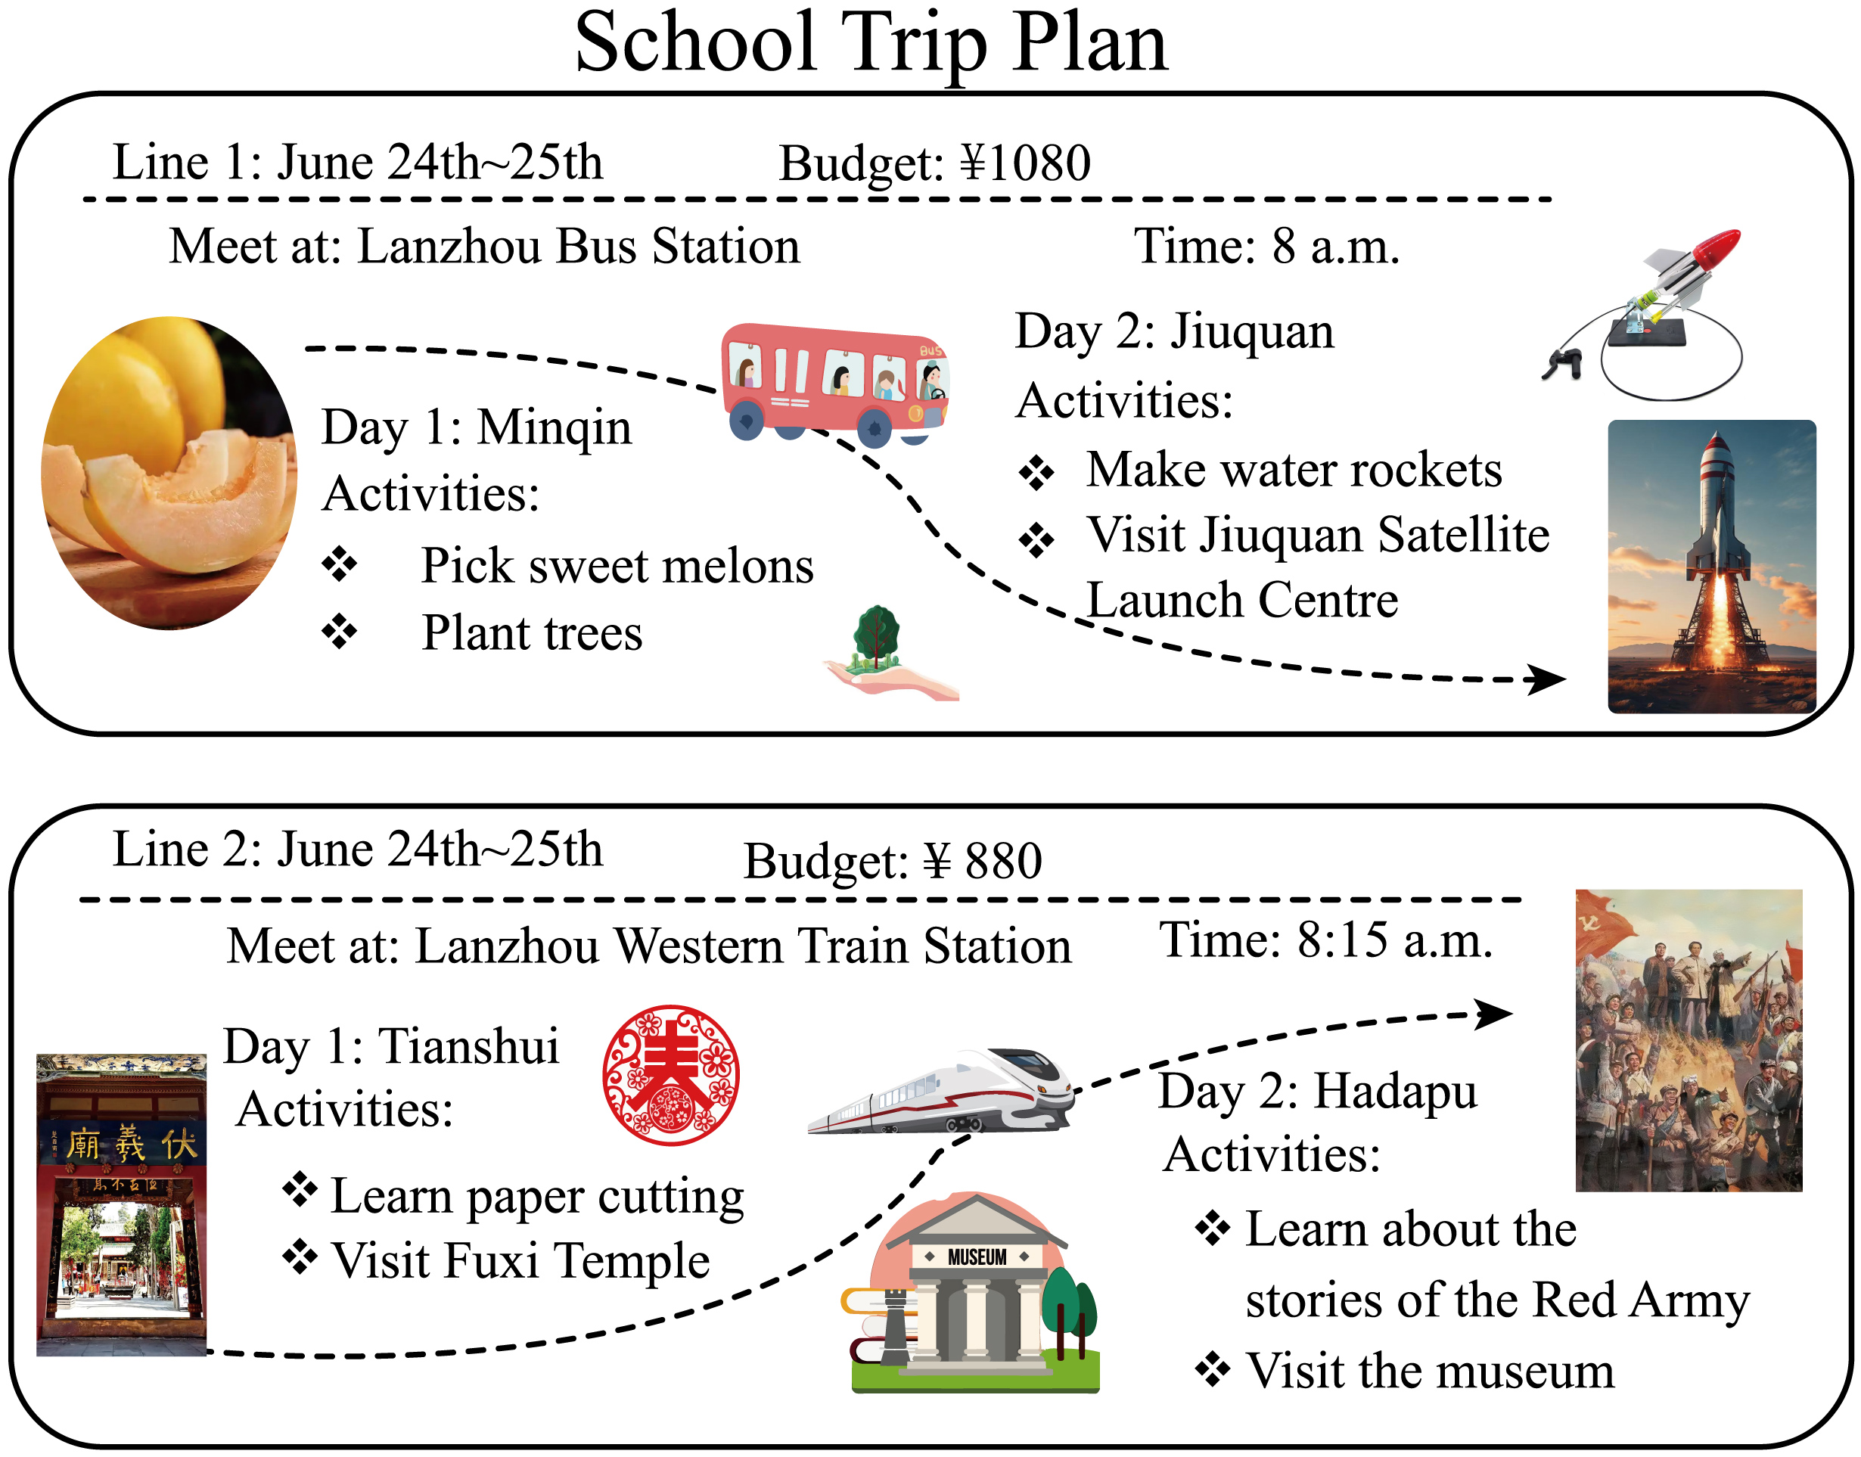

11. Which grade students are going to take the school trip?

A. Grade 6. B. Grade 7. C. Grade 8. D. Grade 9.

12. What can students do in Minqin?

A. Plant trees. B. Make water rockets.

C. Cut paper. D. Visit the museum.

13. If Xinghan chooses Line 1, what is he probably interested in?

A. Culture. B. Climate. C. Space. D. Music.

14. Tengfei plans to spend at most 950 yuan on his trip. Where is he going?

A. Minqin and Jiuquan. B. Tianshui and Hadapu.

C. Minqin and Hadapu. D. Tianshui and Jiuquan.

15. When do the students visit the museum in Hadapu?

A. On May 24th. B. On May 25th.

C. On June 24th. D. On June 25th.

【答案】11. C 12. A 13. C 14. B 15. D

【解析】

【导语】本文是一篇应用文。文章是学生旅行的活动安排。

【11题详解】

细节理解题。根据“Here is a school trip plan for Grade 8 students.”可知，八年级的学生参加这次旅行。故选C。

【12题详解】

细节理解题。根据“Day 1 Minqin”的活动“Plant trees”可知，可以植树。故选A。

【13题详解】

推理判断题。根据“Day 2 Jiuquan”的活动“Visit Jiuquan Satellite Launch Center”可知，可能对太空感兴趣。故选C。

【14题详解】

推理判断题。根据“Budget ￥880”可知，最多950元只能去Tianshui and Hadapu。故选B。

【15题详解】

细节理解题。根据“Line 2: June 24th~25th Day 2 Hadapu”可知，Hadapu的活动在第二天June 25th。故选D。

**B**

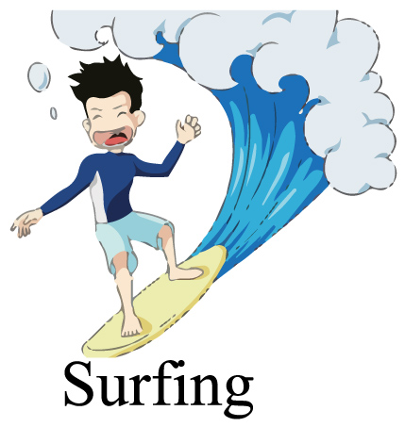

Surfing is a kind of water sport. Surfers use a surfboard to catch and ride the breaking waves.

Surfing originated (起源) in the Polynesian islands of the Pacific Ocean as well as West Africa and Peru. When Polynesians first went and lived in Hawaii about 1200 AD, they brought their love of surfing with them. Surfing was more than a sport to the early Hawaiians. It was an important part of their culture.

Hawaiians carved (雕刻) surfboards from the wood of special trees. The first boards were about 3 to 7 meters long and weighed more than 50 kilos. After World War II, plastic foam (泡沫) board appeared and the shape improved. Today’s surfboard is about 1.5 to 2.7 meters long and 11 to 26 kilos. It is light and flat, and a tail fin is fixed downside. Surfboards come in many different styles, including shortboards, longboards, and funboards.

Surfing was brought to the Western world in the early 20th century. In recent years, surfing has become popular among Chinese young sport lovers. China set up its national surfing team in 2018. In March 2024, a 15-year-old girl called Yang Siqi, from Sichuan Province, became China’s first Olympic surfer.

Surfing is not only about riding waves but about connecting with the ocean and having fun. It’s a sport that combines physical strength, balance and a love for the water. So, if you ever get the chance, give it a try!

16. Surfing started in ________.

①Peru ②West Africa ③the Polynesian islands of the Pacific Ocean

A. ①② B. ①③ C. ②③ D. ①②③

17. The first boards are ________ and ________ than today’s.

A. longer, wider B. wider; heavier

C. longer, heavier D. thicker, longer

18. What is true about paragraph 4?

A. Chinese are all interested in surfing now.

B. China has set up its national surfing team for 10 years.

C. Surfing didn’t become popular in Western world until the 19th century.

D. Yang Siqi was 15 years old when she became China’s first Olympic surfer.

19. Which of the following best shows the structure of the text?

A. 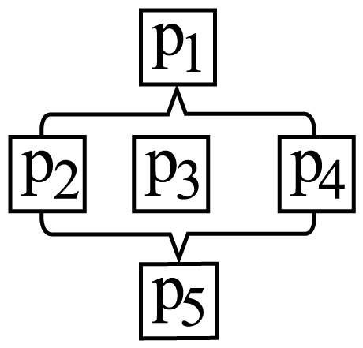 B. 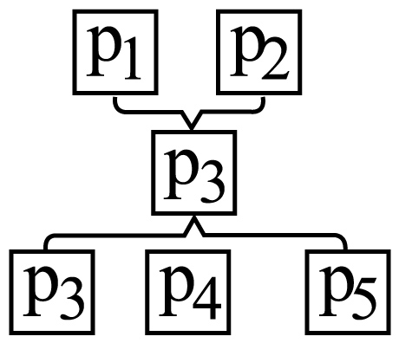 C. 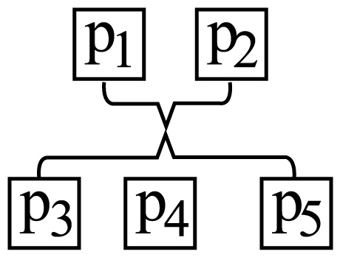 D. 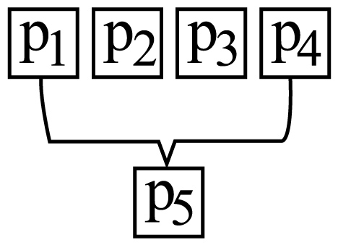

20. Who is the text mainly written for?

A. Art lovers. B. Sports lovers.

C. Cooking lovers. D. Book lovers.

【答案】16. D 17. C 18. D 19. A 20. B

【解析】

【导语】本文主要介绍了冲浪运动的起源、历史演变、冲浪板的改进以及冲浪在中国的普及情况等。

【16题详解】

细节理解题。根据“Surfing originated (起源) in the Polynesian islands of the Pacific Ocean as well as West Africa and Peru.”可知，冲浪起源于太平洋的波利尼西亚群岛，以及西非和秘鲁。故选D。

【17题详解】

细节理解题。根据“The first boards were about 3 to 7 meters long and weighed more than 50 kilos. ”和“Today’s surfboard is about 1.5 to 2.7 meters long and 11 to 26 kilos.”可知，最初的冲浪板更长且更重。故选C。

【18题详解】

细节理解题。根据“In March 2024, a 15-year-old girl called Yang Siqi, from Sichuan Province, became China’s first Olympic surfer.”可知，杨思琪15岁时成为首位奥运冲浪选手。故选D。

【19题详解】

篇章结构题。①段为冲浪的简要介绍；②③④段分别介绍起源、冲浪板演变及中国的冲浪发展；⑤段总结冲浪的意义。图A与之相符，故选A。

【20题详解】

推理判断题。全文围绕冲浪运动展开，目标读者应为运动爱好者。故选B。

**C**

Every bridge is a symbol of the times. Most of them look similar, but there are great differences in the way they are built. Let’s learn about bridges around the world.

**Cable-stayed bridge**

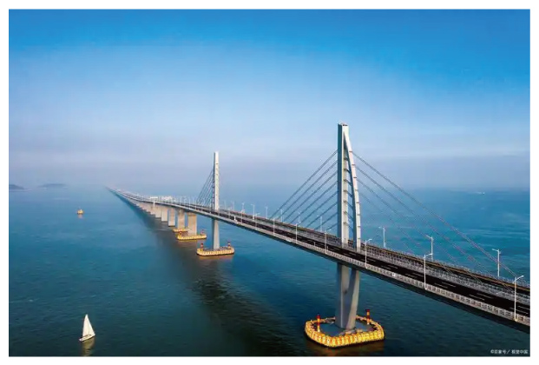

The Hong-Kong-Zhuhai-Macao Bridge (HZMB) is the longest sea-crossing bridge and a kind of cable-stayed bridge. It was opened in 2018. The construction (建造) of the HZMB requires **cutting-edge** technology and careful planning. Its opening proves that humans are making miracles (奇迹) with great effort and wisdom.

**Drawbridge**

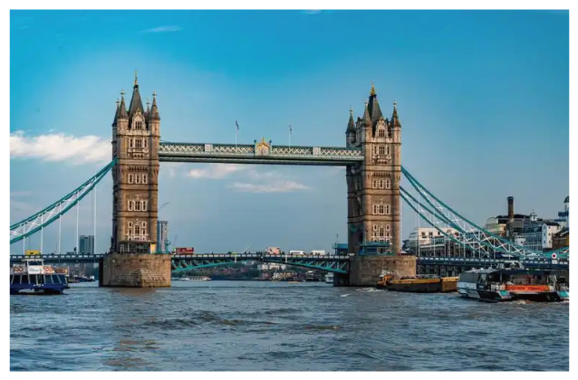

London Tower Bridge has been standing over the River Thames since 1894. The bridge is known for its bascule (桥梁板), and this part can be raised to allow tall ships to pass through. From the top of the bridge, you could enjoy the beautiful views of the River Thames.

**Arch bridge**

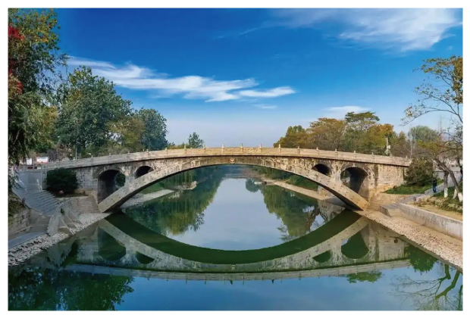

One of the oldest arch (拱) bridges is Zhaozhou Bridge in Hebei Province. It was built by Li Chun of Sui Dynasty about 1,400 years ago. There are two small arches at each side of the big arch. Usually, the river runs through the big arch. When there is a flood (洪水), the river can also run through the four small ones. So today the bridge is still in use.

Arches play an important part in bridges. They are used for spreading the weight they are carrying out. Why not make your own model arch? You just need some paper and a pair of scissors.

|  |  |
| --- | --- |
| Steps:  ①Cut out one large shape and six small shapes. | ②Lay out all of the paper pieces like this. Make sure the large piece will be put in the central place of this arch as it holds the whole arch together. |
| 学科网(www.zxxk.com)--教育资源门户，提供试卷、教案、课件、论文、素材以及各类教学资源下载，还有大量而丰富的教学相关资讯！ V+6pfNvw5vPNAx1ODbqMbQ== | |

Try it, test it and make it better!

21. How many kinds of bridges are mentioned in the text?

A. One. B. Two. C. Three. D. Four.

22. What does the underlined word “**cutting-edge**” mean in paragraph 2?

A. High. B. Low. C. Simple. D. Old.

23. How long has London Tower Bridge been standing over the River Thames?

A. Over 1,400 years. B. Over 100 years.

C. Less than 100 years. D. Less than 7 years.

24. How does the writer end the text?

A. By telling a story. B. By listing numbers.

C. By making a model arch. D. By introducing some bridges.

25. What is the main purpose of writing this text?

A. To tell readers the history of bridges. B. To show readers the views on bridges.

C To advise readers to enjoy and visit. D. To encourage readers to know and practise.

【答案】21. C 22. A 23. B 24. C 25. D

【解析】

【导语】本文主要介绍了三种桥梁类型（斜拉桥、开启桥和拱桥）及其代表建筑，并鼓励读者动手制作拱桥模型。

【21题详解】

细节理解题。根据“Cable-stayed bridge”，“Drawbridge”和“Arch bridge”可知，文章共提到了三种桥。故选C。

【22题详解】

词义猜测题。根据“ The construction (建造) of the HZMB requires cutting-edge technology and careful planning. Its opening proves that humans are making miracles (奇迹) with great effort and wisdom.”可知，港珠澳大桥的建造需要尖端技术和周密规划，它的通车证明，人类正凭借巨大的努力和智慧创造奇迹。“cutting-edge”应指“先进的，领先的”，high technology符合语境。故选A。

【23题详解】

细节理解题。根据“London Tower Bridge has been standing over the River Thames since 1894.”可知，伦敦塔桥自1894年矗立至今，计算至2025年已超过100年。故选B。

【24题详解】

细节理解题。通读全文可知，文章结尾部分通过表格给出制作拱桥模型的步骤并鼓励读者去尝试，属于通过实践操作收尾。故选C。

【25题详解】

主旨大意题。全文通过介绍桥梁类型和结尾的动手实践指导，呼应最后一句“Try it, test it...”的号召性语言，目的是鼓励读者了解和实践。故选D。

**三、任务型完形填空（共10小题; 每小题1.5分, 满分15分）**

阅读下面的短文，用方框中所给词的适当形式填空，使文意通顺，结构正确。（每个单词限用一次）

|  |
| --- |
| technology one when find subway hungry safer you happily ordered |

Dear Peter,

How’s everything going? I’m in Shenzhen, China right now. Although I have learned something about China before, it is my ____26____ time here. What I have experienced changed my opinion about China.

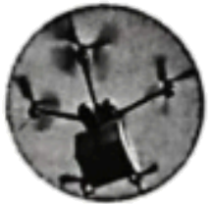

One morning, I planned to go to a park by ____27____. When I walked into the station, I was surprised ____28____ it was so clean and modern. In the park, I saw many people doing Taichi, jogging and dancing ____29____. Everyone was enjoying themselves. At noon, I felt tired and ____30____. Some useful APPs made it convenient for me to live here. So I ____31____ food online. You know what? It was a drone (无人机) that delivered my lunch! High ____32____ has already been a part of Chinese daily life. In the afternoon, I rode a shared electric scooter (共享电动车) around the city and wanted to choose some gifts. However, ____33____ I was going to pay, I found I had left my bag on the scooter. So I went back to look for it at once. It was still there! That’s amazing!

Believe me, there is no place ____34____ and more convenient than China, It is the best choice for _____35_____ next trip.

Yours,

Tom

【答案】26. first

27. subway 28. to find

29. happily

30. hungry 31. ordered

32. technology

33. when 34. safer

35. your

【解析】

【导语】本文主要讲述了作者第一次来到中国深圳经历和感受。

【26题详解】

句意：尽管我之前对中国有所了解，但这是我第一次来这里。根据“Although I have learned something about China before, it is my...time here.”和备选词可知，此处表达“这是我第一次来这里”，one的序数词first“第一”。故填first。

【27题详解】

句意：一天早上，我打算乘地铁去公园。根据“go to a park by...”和备选词可知，此处表达“乘地铁”，by subway“乘地铁”。故填subway。

【28题详解】

句意：当我走进车站时，我惊讶地发现它是如此干净和现代化。根据“I was surprised...it was so clean and modern.”和备选词可知，此处表达“我惊讶地发现”，find“发现”，此处用其不定式形式to find作原因状语。故填to find。

【29题详解】

句意：在公园里，我看到许多人开心地打太极、慢跑和跳舞。根据“doing Taichi, jogging and dancing...”和备选词可知，此处表达“开心地做某事”，用副词happily“开心地”修饰动词。故填happily。

30题详解】

句意：中午，我感到又累又饿。根据“At noon, I felt tired and...”和备选词可知，此处表达“又累又饿”，hungry“饥饿的”符合句意。故填hungry。

【31题详解】

句意：所以我在网上订了食物。根据“food online”和备选词可知，此处表达“在网上订食物”，order“订购”，根据“was”可知，时态是一般过去时，所以此处用动词的过去式。故填ordered。

【32题详解】

句意：高科技已经成为中国人日常生活的一部分。根据“It was a drone (无人机) that delivered my lunch!”和备选词可知，此处表达“高科技”，technology“科技”符合句意。故填technology。

【33题详解】

句意：然而，当我要付款时，我发现我把包忘在滑板车上了。根据“...I was going to pay, I found I had left my bag on the scooter.”和备选词可知，此处表达“当我要付款时”，when“当……时候”，引导时间状语从句。故填when。

【34题详解】

句意：相信我，没有比中国更安全、更方便的地方了。根据“there is no place...and more convenient than China”和备选词可知，此处表达“没有比中国更安全的地方了”，用比较级safer“更安全的”表示。故填safer。

【35题详解】

句意：这是你下次旅行的最佳选择。根据“It is the best choice for...next trip.”和备选词可知，此处表达“这是你下次旅行的最佳选择”，用形容词性物主代词your“你的”修饰名词trip。故填your。

**四、任务型阅读理解（共5小题: 每小题2分, 满分10分）**

阅读下面短文, 按要求完成后面小题。

**From Tradition to the Modern**

**Customs and Tradition**

During the Dragon Boat Festival, Chinese always put mugwort leaves on doors or windows to make the air fresh and keep flies and other insects away. Mugwort, a kind of plant, is highly valued for its medical use in TCM (Traditional Chinese Medicine). Chinese have been making use of herbs (草药) like mugwort to help people improve health or treat illness for thousands of years.

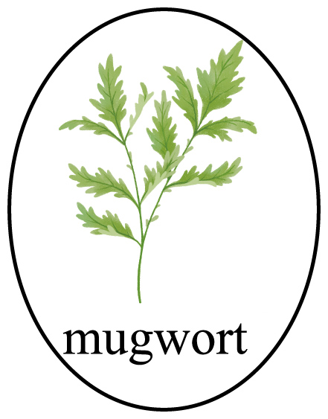

▲

Nowadays, we are seeing more interest in TCM especially among the young. ①Influenced by TCM ideas, some young people stop having icy drinks. They accept hot Chinese herbal tea, instead. When people feel ill, some choose to go to TCM hospitals and clinics for treatment. With the spread of TCM, some schools start courses about it. For example, students learn to make joss sticks (线香) with herbs in class. More TCM programs appear on TV and the Internet, which helps people form better living habits.

**Ideas and Spirit**

In fact, the ideas of Traditional Chinese Medicine are everywhere around us. Following the natural rules can make us healthier. As an old saying goes, “Early to bed, early to rise.” TCM also pays more attention to the balance of diet. Different coloured foods are friendly to different parts of the body. White food is good for lungs, red for heart…If a body is like a tree, TCM focuses on its root (根). It aims at keeping the body and mind in harmony (和谐).

Chinese traditions are making a difference to our modern life.

36. Where do Chinese put mugwort leaves during the Dragon Boat Festival?

________________________________________

37. 请根据文中①处的句意, 补全下面的句子, 使句意不变, 完整通顺。（每空仅限一词）

Influenced by TCM ideas, some young people ________ ________ having icy drinks.

38. What idea does the old saying “Early to bed, early to rise.” tell us? (每空仅限一词)

We should follow the ________ ________.

39. 请为第二段 ▲ 处选择一个恰当的小标题。

A. Science and Skill B. Practice and Spread

40. Share one of your healthy living habits based on TCM, and give the reason.

________________________________________

【答案】36. On doors or windows.

37. ①. give ②. up

38. ①. natural ②. rules 39. B

40. I have a balanced diet because TCM emphasizes the balance of diet and different colored foods are beneficial to different parts of the body.

【解析】

【导语】本文是一篇说明文。文章主要讲述了中国传统习俗与现代生活，特别是中医在现代生活中的应用与影响。

【36题详解】

根据“During the Dragon Boat Festival, Chinese always put mugwort leaves on doors or windows to make the air fresh and keep flies and other insects away.”可知，中国人端午节时总是把艾草放在门上或窗户上。故填On doors or windows.

【37题详解】

根据文中①处的句意“受中医思想的影响，一些年轻人不再喝冷饮了。”可知，此处需要填入的词组应表达“不再做某事”的意思，可以用“give up”来表示。又因为原句是一般现在时，且主语“some young people”是复数，所以动词用原形。故填give；up。

【38题详解】

根据“Following the natural rules can make us healthier. As an old saying goes, ‘Early to bed, early to rise.’”可知，古老的谚语“早睡早起”告诉我们要遵循自然规律。故填natural；rules。

【39题详解】

根据“Nowadays, we are seeing more interest in TCM especially among the young...With the spread of TCM, some schools start courses about it...More TCM programs appear on TV and the Internet, which helps people form better living habits.”可知，本段主要讲述了中医的实践和传播，因此选项B“实践与推广”作为小标题最为恰当。故选B。

【40题详解】

开放性作答，结合实际，言之有理即可。参考答案为I have a balanced diet because TCM emphasizes the balance of diet and different colored foods are beneficial to different parts of the body.

**五、词汇考查（共10小题: 每小题1分, 满分10分）**

**用括号内所给词的适当形式填空。**

41. Don’t ________ (stand) against the door in the lift.

【答案】stand

【解析】

【详解】句意：不要在电梯里靠着门站着。根据“Don’t”可知，这是一个否定祈使句，其结构通常为“Don't + 动词原形 + 其他.”，表示“不要做某事”。“stand”意为“站立”，在这里使用其原形形式。故填stand。

42. Doctors say we should drink enough ________ (water) every day.

【答案】water

【解析】

【详解】句意：医生说我们每天应该喝足够的水。根据“drink enough...”可知，此处表达“喝足够的水”，water“水”，为不可数名词，在这里作drink的宾语。故填water。

43. Today is my ________ (brother) birthday. I want to make a bowl of long noodles for him.

【答案】brother’s

【解析】

【详解】句意：今天是我弟弟的生日。我想为他做一碗长寿面。根据“Today is my...birthday.”可知，此处表达“我弟弟的生日”，应该使用名词所有格形式来表示所属关系，即在名词“brother”后加“’s”。故填brother’s。

44. His cousin keeps on painting in order to become an ________ (art).

【答案】artist

【解析】

【详解】句意：他的表弟一直坚持画画，为的是成为一名艺术家。根据“in order to become an...(art)”可知，此处指成为一名艺术家，artist“艺术家”，an后接其单数形式。故填artist。

45. Lanzhou ________ (receive) a large number of visitors every year.

【答案】receives

【解析】

【详解】句意：兰州每年都接待大量的游客。根据“every year”可知，时态为一般现在时。主语“Lanzhou”是第三人称单数，谓语动词要用第三人称单数形式。receive“接待；收到”，第三人称单数形式是“receives”。故填receives。

46. I am 15 years old and I’m able to look after ________ (I) well.

【答案】myself

【解析】

【详解】句意：我15岁了，我能够很好地照顾自己。根据“I’m able to look after...well.”可知，此处表达“我能够很好地照顾自己”，look after oneself表示“照顾自己”，因此应该使用反身代词“myself”来指代主语“I”自己。故填myself。

47. Look, the kids are ________ (jump) rope in the sports field during the 15-minute break.

【答案】jumping

【解析】

【详解】句意：看，孩子们在15分钟的课间休息时正在操场上跳绳。根据“Look”以及“are”可知，此处描述的是正在发生的动作，应使用现在进行时，其结构为“be动词+动词的现在分词”。jump“跳”，其现在分词形式为“jumping”。故填jumping。

48. Please check your paper ________ (careful) after finishing it.

【答案】carefully

【解析】

【详解】句意：完成后请仔细检查你的试卷。根据“check”可知，此处需要一个副词来修饰动词。careful “仔细的”是形容词，其副词形式是carefully“仔细地”。故填carefully。

49 The sweet memories in junior high school will be ________ (remember) forever.

【答案】remembered

【解析】

【详解】句意：初中时的美好回忆将被永远铭记。根据“The sweet memories in junior high school will be...(remember) forever.”可知，此处指美好记忆将被铭记，用被动语态“be done”，空前已有be，空处应是remember的过去分词remembered。故填remembered。

50. Keep studying hard in the future because ________ (learn) is a lifelong journey.

【答案】learning

【解析】

【详解】句意：在未来继续努力学习，因为学习是一个终生的旅程。根据“because...is a lifelong journey”可知，此句是原因状语从句，该从句缺少主语；应用所给单词的动名词形式“learning”作从句的主语。故填learning。

**六、书面表达（满分15分）**

51. 据报道, 某小区花墙长势喜人, 吸引众多游客前来打卡拍照。假如你是该小区住户, 请根据以下内容为小区写一篇英文宣传报道, 向某英文杂志旅游专栏投稿。

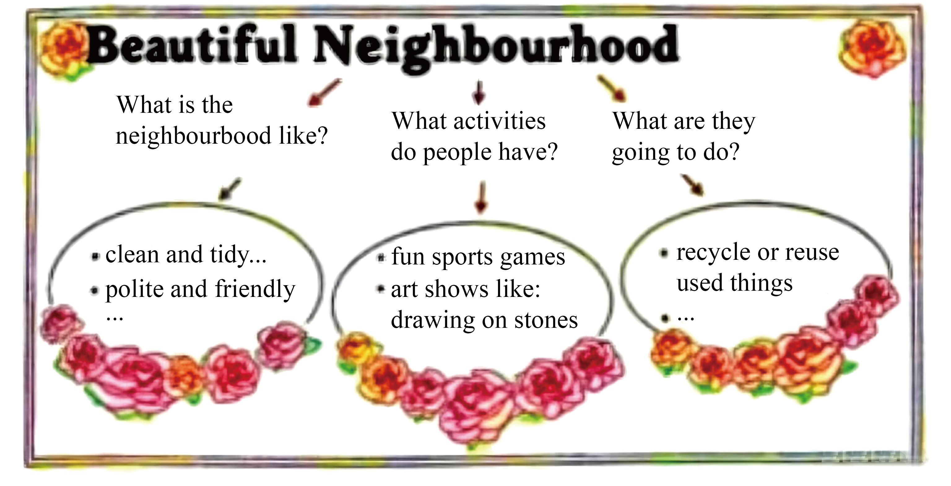

要求: 1. 报道应包括图示所有要点:

2. 条理清晰, 行文连贯, 可适当发挥;

3. 文中不能出现真实的人名、地名、校名等信息;

4. 词数80词左右, 文章标题和开头已给出, 请抄写在答题卡上。（不计入词数）

Beautiful Neighborhood

It is reported that the lovely flowers of my neighbourhood have attracted lots of tourists.

__________________________________________________________________________________________________________________________________________________________________________________________________________________________________________________________________________________________________________________________________________________________________________________________________________________________________________________________________________________________________________________________________________.

【答案】例文：

Beautiful Neighborhood

It is reported that the lovely flowers of my neighbourhood have attracted lots of tourists. Our neighborhood, which is always clean and tidy, is full of friendly and polite people.

Residents here enjoy various activities. There are exciting sports games like volleyball tournaments and interesting art shows where people draw on stones. These activities make our life colorful.

In the coming days, we’ll focus on recycling and reusing used things. We aim to turn waste into useful items, making our neighborhood a more eco-friendly and charming place.

【解析】

【详解】[总体分析]

①题材：本文是一篇材料作文。

②时态：时态主要为“一般现在时”和“一般将来时”。

③提示：写作要点已给出，考生应注意要点齐全，可适当补充。

[写作步骤]

第一步，表明写作意图。文章开头直接描述了社区的美丽景象，以此引出下文对社区的详细介绍。

第二步，具体阐述写作内容。描述社区环境并介绍社区活动。

第三步，书写结语。介绍未来环保计划的展望，传达了作者对社区的热爱和期待。

[亮点词汇]

①attract吸引

②various各种各样的

③eco-friendly环保的

[高分句型]

Our neighborhood, which is always clean and tidy, is full of friendly and polite people. (which引导的定语从句)